**Q1:**

clc

clear all

format compact

syms x y

z = input('Enter the two dimensional function f(x,y): ');

x1 = input('enter the x value at which the derivative has to be evaluated: ');

y1 = input('enter the y value at which the derivative has to be evaluated: ');

z1 = subs(subs(z,x,x1),y,y1)

ezsurf(z,[x1-2 x1+2])

f1 = diff(z,x)

slopex = subs(subs(f1,x,x1),y,y1);

[x2,z2]=meshgrid(x1-2:.25:x1+2,0:0.5:10);

y2=y1*ones(size(x2));

hold on

h1=surf(x2,y2,z2);

set(h1,'FaceColor',[0.7,0.7,0.7],'EdgeColor','none')

t=linspace(-1,1);

x3=x1+t;

y3=y1*ones(size(t));

z3=z1+slopex*t;

line(x3,y3,z3,'color','blue','linewidth',2)

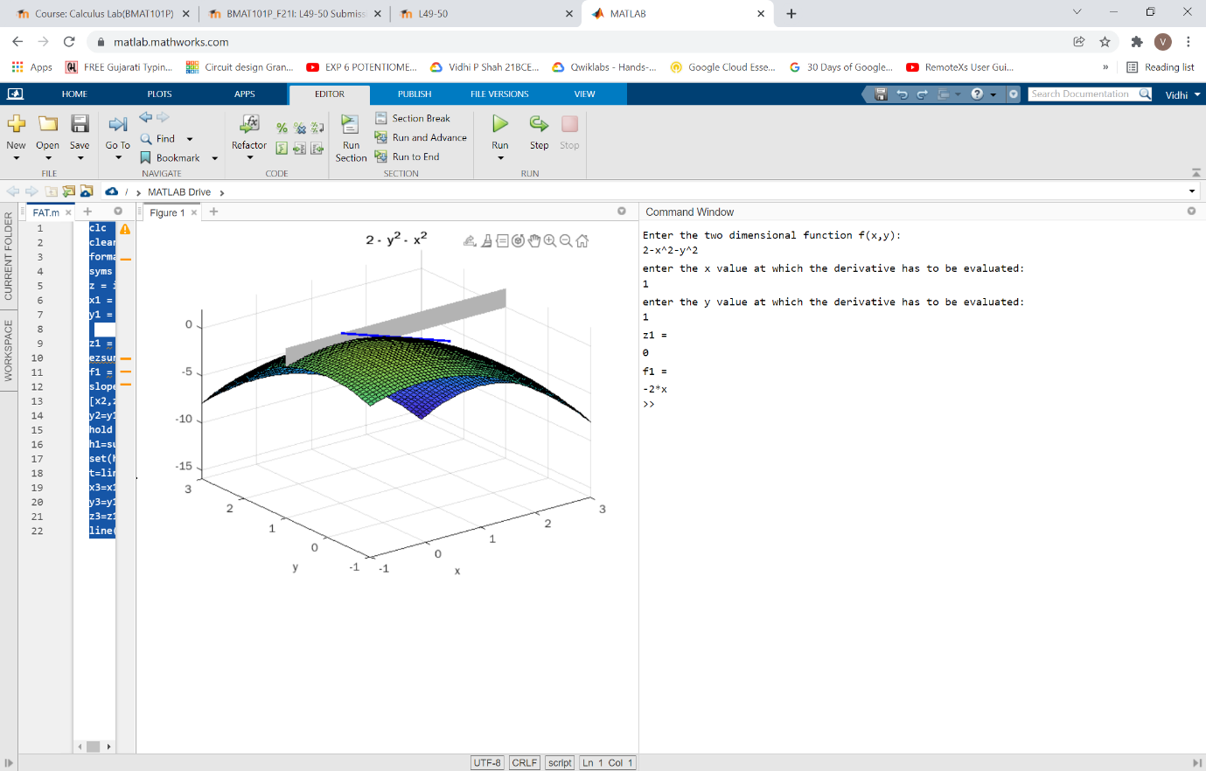

**Q2:**

clc

clear all

syms x y

f=input('enter the function f(x,y):');

F=gradient(f)

P = inline(vectorize(F(1)), 'x', 'y');

Q = inline(vectorize(F(2)), 'x','y');

x = linspace(-2, 2, 10);

y = x;

[X,Y] = meshgrid(x,y);

U = P(X,Y);

V = Q(X,Y);

quiver(X,Y,U,V,1)

axis on

xlabel('x')

ylabel('y')

hold on

ezcontour(f,[-2 2])

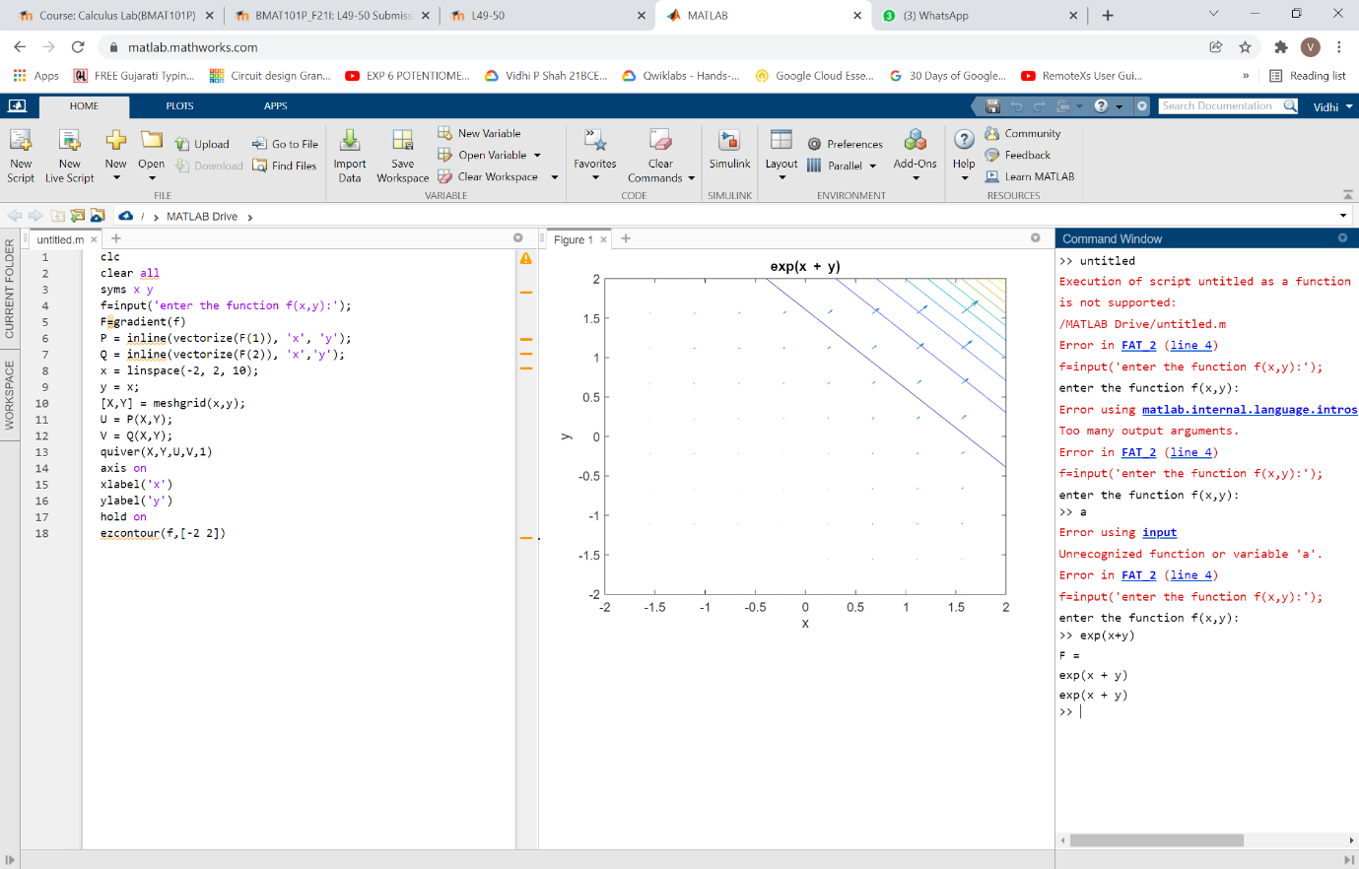



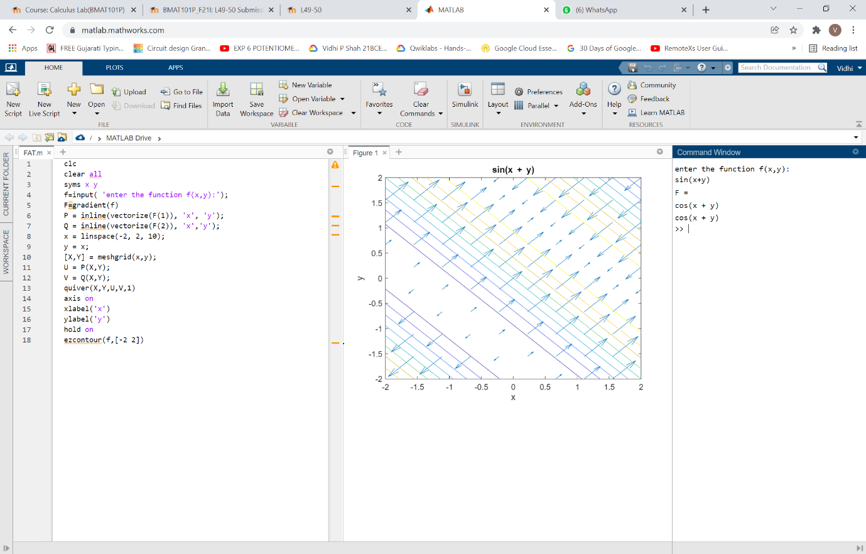

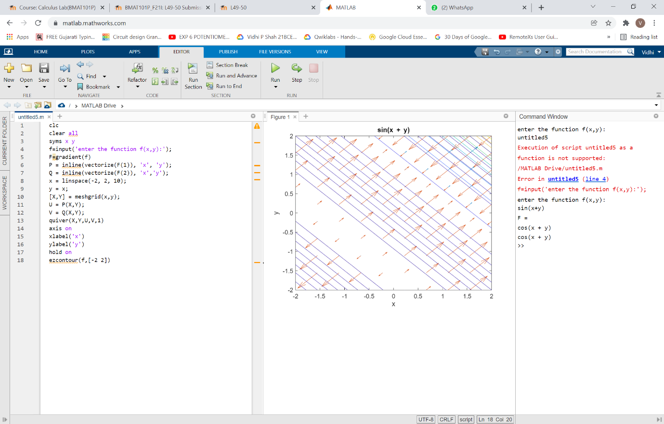

**Q3:**

**Debug:**

clc

clear all

syms x y z

I=int(int(sqrt(1-x^2-y^2),y,0,sqrt(1-x^2)),x,0,1)

viewSolid(z,0+0*x*y,sqrt(1-x^2-y^2),y,0+0*x,sqrt(1-x^2),x,0,1);

axis equal; grid on

axis on

xlabel('x')

ylabel('y')

zlabel('z')

**Original:**

syms x y z

I=int(int(sqrt(1-x^2-y^2), y,0, sqrt(1-x^2)), x,0,1)

viewSolid (z,0+0*x*y,4-2*x-2*y, y,0+0*x,2-x, x,0,2) ;

axis equal; grid on

axis on

xlabel('x')

ylabel('y')

zlabel('z'

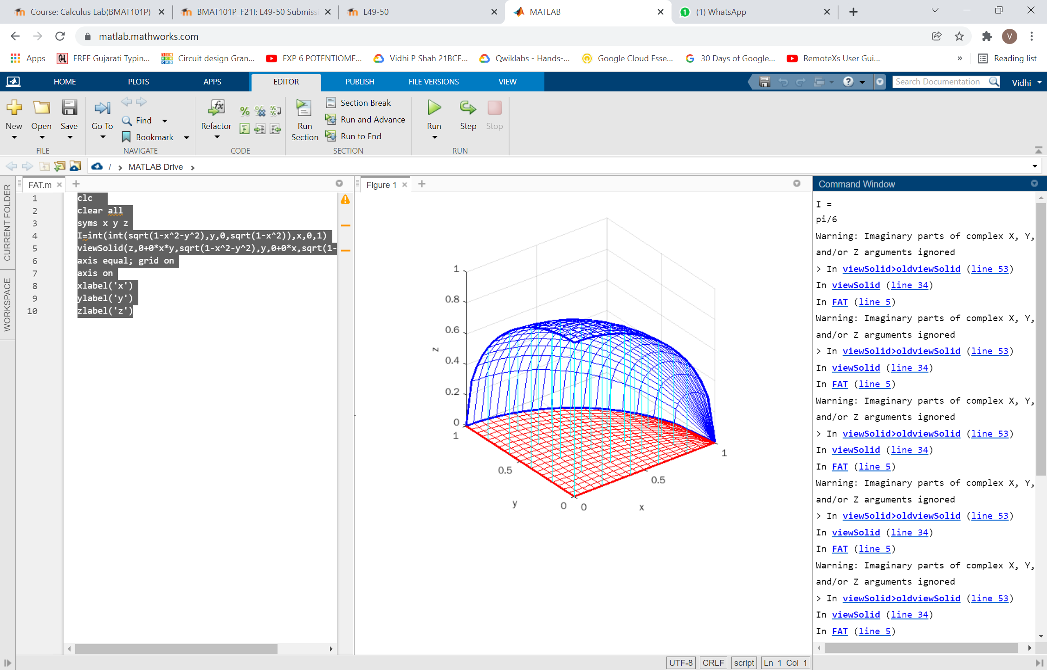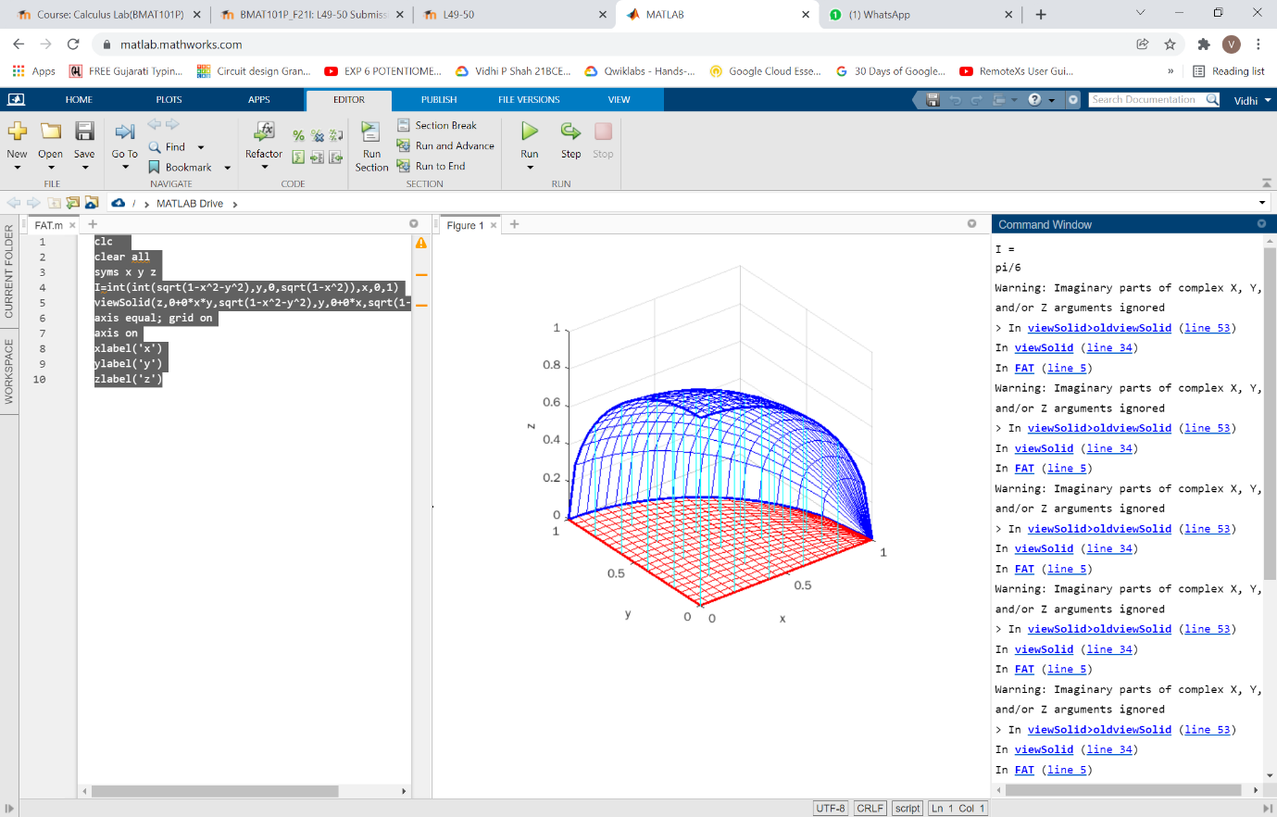

**Q4:**

**DEBUG:**

clc

clear all

syms x

f=input('enter the function f(x):');

a=input('enter lower limit of x ');

b=input('enter the upper limit of x');

n=input('number of intervals');

z=int(f,a,b)

value = 0;

dx = (b-a)/n;

for k=1:n

c = a+k*dx;

d=subs(f,x,c);

value = value + c;

end

value = dx*value

ezplot(f)

rsums(f, a, b)

**Original:**

syms x

f=input('give the function')

a=input('lower limit')

b=input('upper limit')

n=input('number of intervals')

z=int(f,a,b)

value=0;

dx=(b-a)/n;

for k=1:n

    c=a+k*dx;

    d=subs(f,x,c);

    value=value+c

end

value=dx*value

ezplot(f,[a b])

z=int(f,a,b)

rsums(f,a,b)